Ward and tordai Fitting Program – “Read me”
Updated by Kyle Caldwell – 8/14/13
IMPORTANT NOTE: All of the files must remain in the Ward and Tordai folder in order for the program to operate properly. In particular there must be a folder named pictures containing the images for the adsorption isotherms as .gif files

Getting acquainted with the program
- The program console
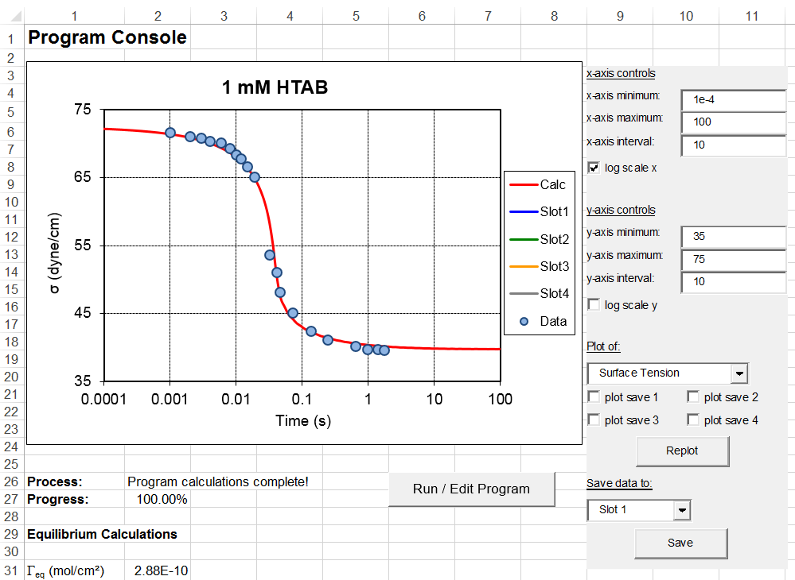
  - This is the main interface with the program. Here we can view the calculated results and the experimental data on the graph. Note that the graphics controls are to the right of the graph itself. In order to change the axis labels etc. the replot button must be pushed. The user can switch between plots of the surface tension, surface excess and subsurface concentration through the dropdown menu in this console. Additionally the most recently calculated data may be saved into one of four “slots” by using the save to drop down menu and “save” button. These results can be plotted alongside the experimental data and current results for comparison.
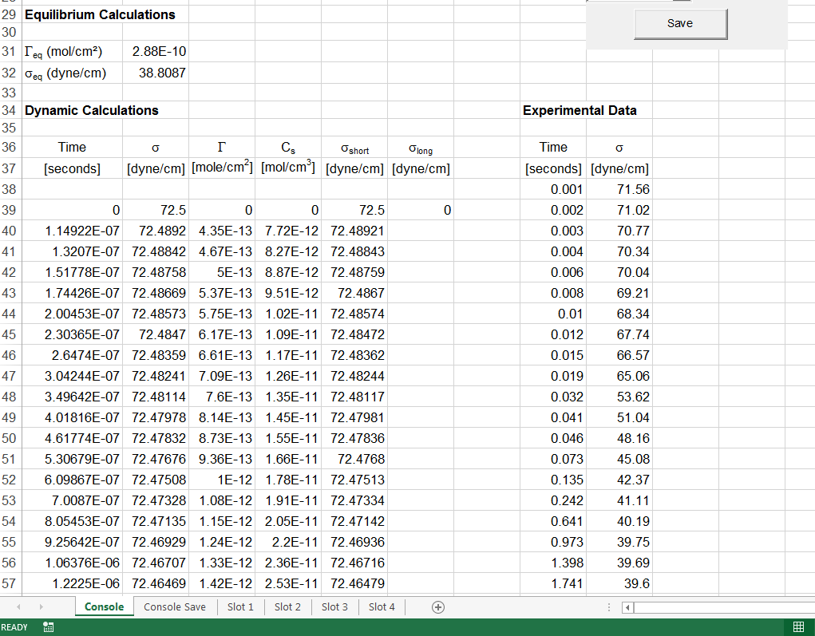
  - Further down the page we see sections reporting the equilibrium calculations, the dynamic calculations (which represent the analytical solution) and an area to post the experimental data. IT IS IMPORTANT THAT THE EXPERIMENTAL DATA DOES NOT CONTAIN A VALUE OF 0 FOR THE FIRST TIME POINT.

Running the calculations
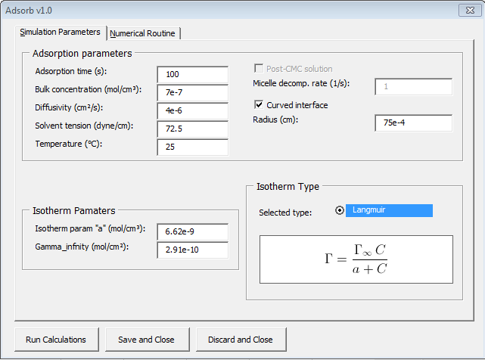
- Under the Simulation Parameters enter the appropriate values
  - Adsorption time sets the value for the last time point the program will evaluate
  - Bulk Concentration – the concentration of the solution investigated
  - Diffusivity of the surfactant – Something on the order of 1e-6 is a good initial guess
  - Solvent tension – surface tension of the solvent (~72.5 for water)
  - Temperature – ambient temperature (approximately 20-25)
  - Isotherm parameter “a” – the characteristic concentration of the surfactant
    - Proper initial estimates are provided in the handout for each surfactant
  - Gamma infinity – the maximum surface coverage of the surfactant assuming a close pack monolayer.
    - Proper initial estimates are provided in the handout for each surfactant
  - Post-CMC solution – for use when above the CMC and micelles break down
  - Curved interface – curvature of the interface adds additional terms to the Ward and Tordai equation, the effects are minimal for curvatures greater than ~50 microns
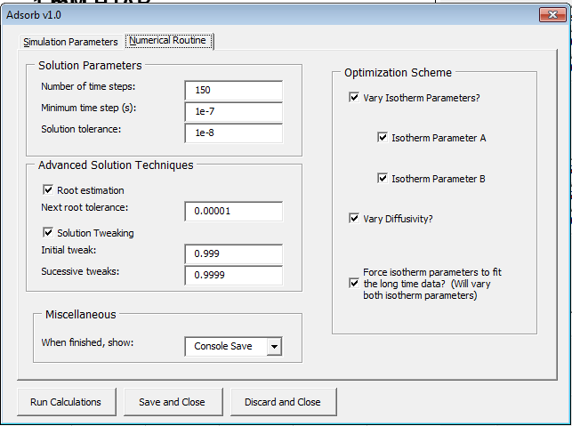
- Under the numerical solutions tab
  - Solution parameters
    - The number of time steps to be evaluated (100 is usually enough)
    - The minimum time step to be used (10e-7 or 10e-8 is usually sufficient)
    - Solution tolerance (1e-8 is usually ok)
  - Advanced solution techniques
    - Root estimation and solution tweaking both provide educated guesses towards the next solution to the Ward and Tordai equation, ultimately speeding up convergence. The values above are appropriate.
  - Miscellaneous
    - When finished the specified sheet can be displayed immediately
  - Optimization Scheme
    - Here the user can vary the isotherm parameters and the diffusivity individually or simultaneously. Isotherm parameter A refers to “a” and Isotherm parameter B refers to Gamma_infinity
    - Additionally the isotherm parameters can be constrained to fit the long time experimental data ensuring that the proper behavior is captured.
- Hit “Run Calculations” to start the software. “Save and close” will store the parameters entered and then close the form without evaluating the Ward and Tordai equation. “Discard and Close” will discard all changes and close the form.

Viewing the results
- The results will automatically be plotted in the main console and the calculated values will populate the “Dynamic Calculations” section of the Console sheet
- If the isotherm parameters or the diffusivity were varied the data must be saved to a slot before they can be retrieved
  - Select a slot to save the data from the drop down menu
  - Click save
  - Go to the sheet where you saved the data
  - The final parameters are listed here
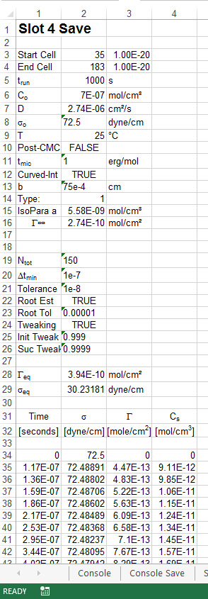

Other notes
- The Console save sheet
  - The Console save sheet saves the initial parameters the user input to the program, but does not include the final parameters if they were allowed to vary.
- Solution did not converge
  - Sometimes if the initial guesses lead to a solution extremely far from the experimental data the parameter optimization will not converge
    - In order to prevent this play with the isotherm parameters manually until a qualitative good fit is observed with the data
  - Problems may also arise if the tolerance is too strict, or there are not enough data points evaluated

